Office of the Controller Job Aid
Responsible Unit | Payroll | June 26, 2023
Title | Payroll Direct Deposit Authorization Form

- The Central Payroll Bureau, State of Maryland (CPB) Payroll Direct Deposit Authorization form is required to be typed, printed, and with wet signature in black ink.
- Hand-written form will be returned by CPB.
- CPB takes about 2 pay periods to process this form.
- Employees are encouraged to complete a new form if continue receiving paper checks after 2 pay periods.

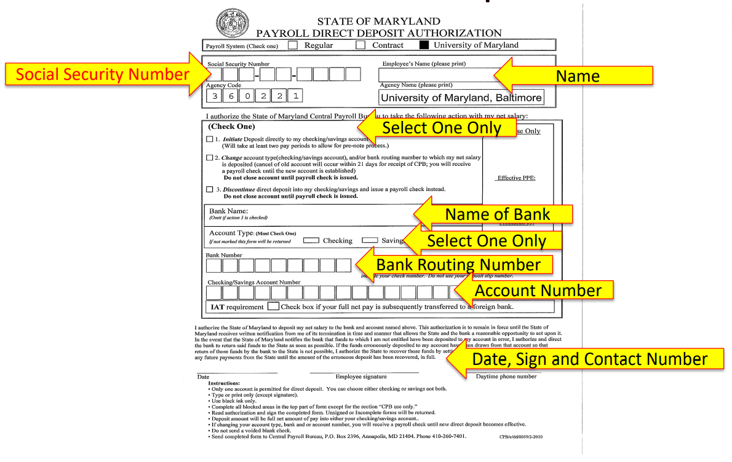

Direct Deposit Form can be found at: Direct Deposit Form (umaryland.edu)
- New employees are encouraged to complete the online form.
- Completed form to be submitted at Onboarding.
- If new employees did not submit the form during Onboarding, the form should be submitted to their department payroll rep.
- Current employees should submit changes via the State Payroll Online Service Center (POSC) at Payroll Online Service Center (marylandtaxes.gov)
The form must be completed in its entirety:
- Payroll System- University of Maryland is checked on the online Direct Deposit Form
- Social Security Number- Enter the Social Security Number (must match employee’s Social Security Card)
- Employee’s Name- Enter employee’s name (must match employee’s Social Security Card)
- Agency Code- The Agency Code for UMB is prefilled with 360221 on the online form.
- Check One- Check Only 1 box.
- Bank Name- Enter the name of your bank.
- Account Type- Select either Checking or Savings
- Bank Number- Enter the Bank Routing Number
- Checking/Savings Account Number- Enter the Account Number
- Date, Employee Signature, Daytime Phone Number- Enter the Date the form is completed, sign in black ink, and enter the Contact Phone Number
Completed form must be submitted to the Department Payroll Representative. The department payroll rep can be found at: Payroll Reps - Payroll Services (umaryland.edu)

