Office of the Controller Job Aid
Responsible Unit | Payroll | June 26, 2023
Title | Review Form MW507

- This form is required to be typed, printed, and with wet signature in black ink. All hand-written form will be returned by Central Payroll Bureau, State of Maryland (CPB).
- CPB takes about 2 pay periods to process this form.
- Employees are encouraged to complete a new form if changes have not been made after 2 pay periods. It is possible the form is being returned by CPB.
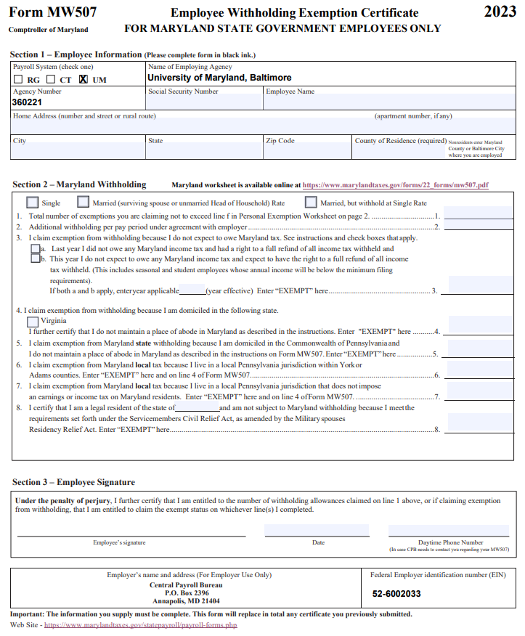

CPB uses Form MW507 for (1) Tax withholding purposes and (2) Change of Address. An original form with wet signature is required for new employees. After review, completed form will be sent to CPB for processing. OOTC-Payroll Services and Human Resources do not keep copies of this form. Employees who filed ‘Exempt’ from tax withholding must file a new form and submit it by February 15 of each year.
Form MW507 for foreign national employees must be sent with their Glacier packet.
CPB has not processed your MW-507 if your paper paycheck or Check Advice:
- Do not show your address.
- Marital status, exempt information, and County code show different information than the form you completed.
- Employees may need to re-submit a new form if the information is not appearing on paycheck for more than 2 pay periods.
- Late submission will result in maximum tax withheld. Employee must file taxes at the end of the year to claim tax refund because CPB will not issue tax refund.
Form MW-507 can be found at: Employee's Withholding Certificate (Federal & State) - Payroll Services (umaryland.edu)
New Employees
- Complete Form MW 507 on our website as the required university information have been prefilled. After completion, print it out, and sign it with black ink.
- Completed form to be submitted at Onboarding.
- If new employees did not submit the form during Onboarding, the form should be submitted to their department payroll rep.
Current Employees
- Current employees should submit changes via the State Payroll Online Service Center (POSC) at Payroll Online Service Center (marylandtaxes.gov)

The form must be completed in its entirety.
Section 1- Employee Information
- Payroll System (check one)- UM is checked on the online Form W-4
- Name of Employing Agency- University of Maryland, Baltimore is prefilled on the online form
- Agency Number- The Agency Number for UMB is prefilled with 360221 on the online form
- Social Security Number- Enter the Social Security Number (must match employee’s Social Security Card)
- Employee Name- Enter employee’s name (must match employee’s Social Security Card)
- Home Address/City/State/Zip Code- Enter your complete address where your paper paycheck(s) and Form W-2 will be mailed.
- County of Residence- County, and not Country
Section 2- Maryland Withholding
- Filing status- Check one of the boxes- Single, Married, or Married, but withhold at Single Rate
- Use the exemption worksheet MW507 2022 050422 (marylandtaxes.gov)
- Required field unless employee is exempt from State taxes. Enter a number, usually between 0 and 5, the larger the number, the fewer taxes will be taken out each pay period.
- Employee can choose to write in write in a dollar amount he/she wants withheld from each pay period to reduce tax burden comes tax time
  - This is for individuals who anticipate owing taxes. Most employees leave this blank.
- Complete this line only if an employee is filing exempt from State taxes.
  - Check Boxes 3(a) and 3(b), enter the current year, and write in ‘Exempt.’
  - Must leave Line #1 and Line #2 blank if completing Line 3
- For VA residents only
- Line 5 – Line 7 For PA residents only
- For Military Spouses only
  - Completing Line 8 must also complete Form MW507M, and attach a copy of the employees’ dependent military ID card issued by the US Dept of Defense
Section 3- Employee Signature
- Employee’s Signature- Sign and date in black ink
- Daytime Phone Number- Enter contact phone number.
Completed form must be submitted to the Department Payroll Representative. The department payroll rep can be found at: Payroll Reps - Payroll Services (umaryland.edu)
Note: Terminated employees should complete a new Form MW507 (Section 1 and 3 only) and write “For W-2 purposes” on top right corner of the form. Employee’s end of year Form W-2 will be mailed to the address listed on the form

